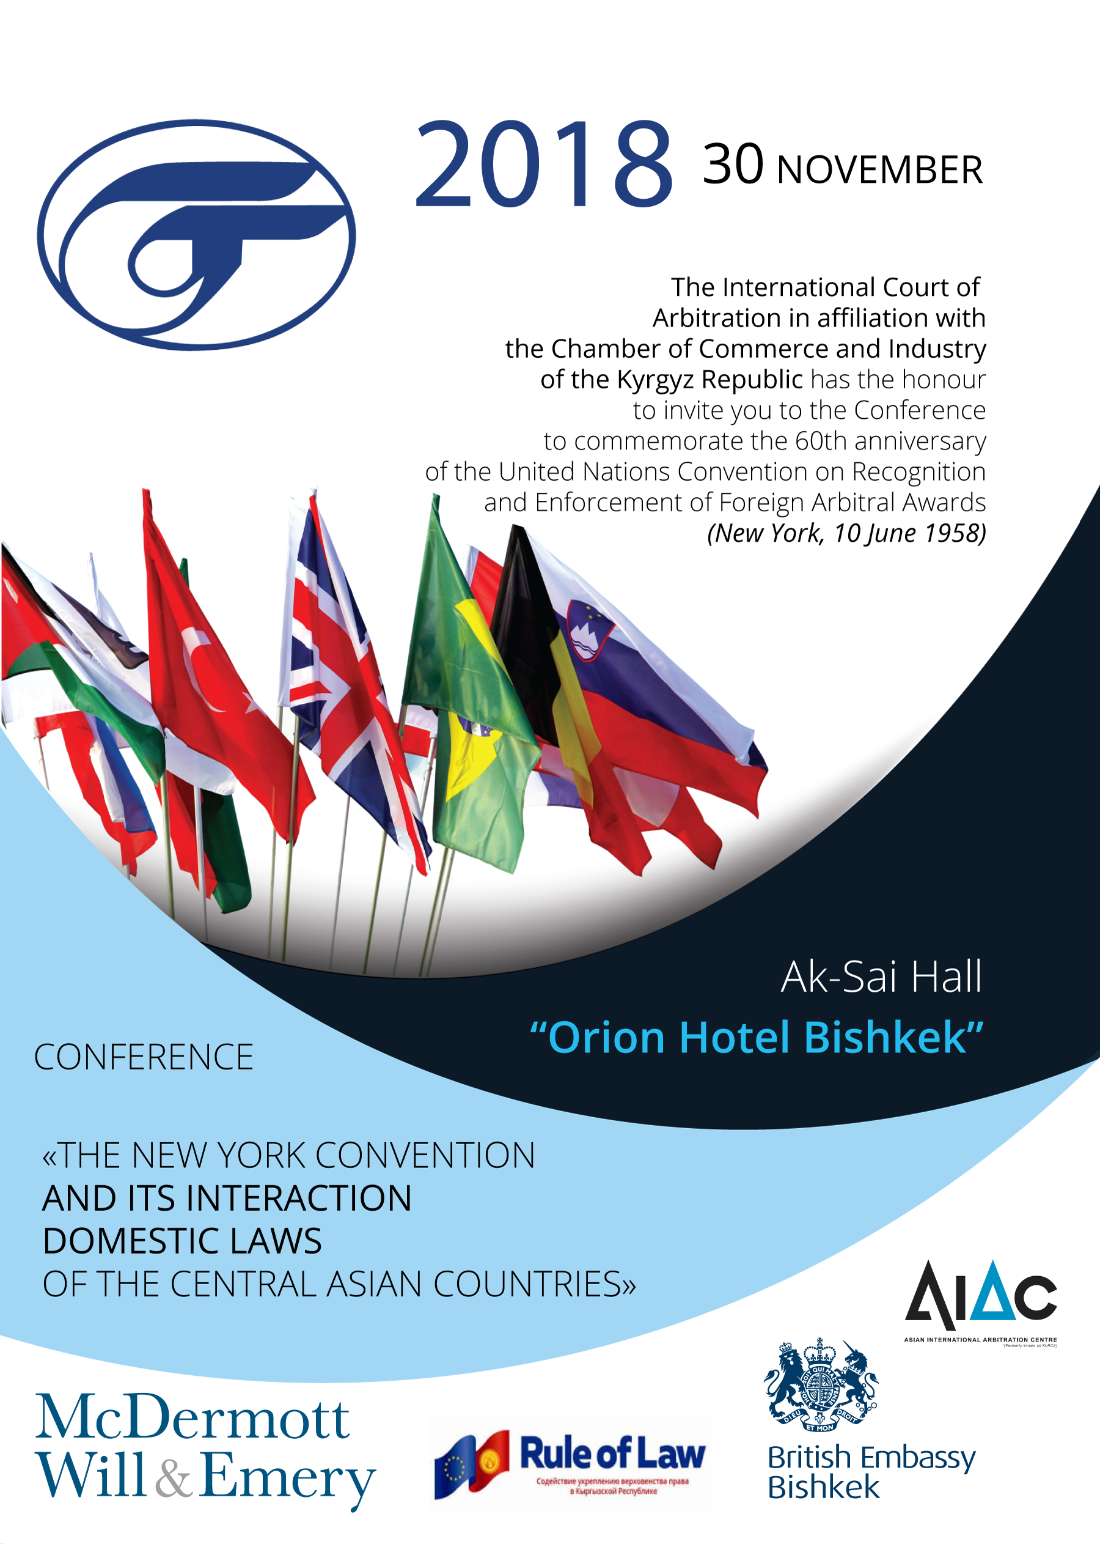
INTERNATIONAL COURT OF ARBITRATION
IN AFFILIATION WITH THE CHAMBER OF COMMERCE AND INDUSTRY
OF THE KYRGYZ REPUBLIC

office 1, 4th floor, 89, Shopokova Str., “Mega-Komfort” Trade Centre
720021, Bishkek, Kyrgyz Republic, phone. +996(312)383005; +996(312)438977
web site: www.arbitr.kg, e-mail: arbitr@elcat.kg

The International Court of Arbitration in affiliation with the Chamber of Commerce

and Industry of the Kyrgyz Republic has the honour

to invite you to the Conference to commemorate the 60th anniversary

of the United Nations Convention on Recognition and Enforcement of Foreign Arbitral Award (New York, 10 June 1958)

«THE NEW YORK CONVENTION AND ITS INTERACTION
DOMESTIC LAWS OF THE CENTRAL ASIAN COUNTRIES»

Date: November 30, 2018
Venue: “Orion Hotel Bishkek”, Aksai-hall, Bishkek, Kyrgyz Republic.
Conference is organized by: The International Court of Arbitration in affiliation with the Chamber of Commerce and Industry of the Kyrgyz Republic.
Sponsors: The British Embassy in Bishkek and the European Union Project “Promotion of Rule of Law in the Kyrgyz Republic.
Partners: Asian International Arbitration Centre (AIAC).
Goals: Examine the interaction between the New York Convention and internal procedural legislation of the Central Asian countries. Exchange of experiences of experts from different jurisdictions in Alternative Dispute Resolution.

Participants:
- Arbitrators, counsels and in-house counsels
- Mediators
- Business associations
- State authorities
- Mass Media

REGISTRATION FEES:
USD 100 for attending the conference and two trainings on “Arbitrator’s ethics” and “Rules of evidence in International Arbitration”.
Registration fee includes: attendance to the conference and trainings, materials, coffee-break, lunch and certificates.
OR
USD 50 for attending the conference (30 November 2018);
USD 50 for the training on “Arbitrator’s ethics” (1 December 2018);
USD 50 for the training on “Rules of evidence in International Arbitration” (2 December 2018).

USD 30 for the Gala Dinner dedicated to the 60th anniversary of the United Nations Convention on Recognition and Enforcement of Foreign Arbitral Award.

PAYMENT RECEIVING INSTITUTION DETAILS:
Institution name: Public Foundation «International Court of Arbitration in affiliation with CCI KR»
GCEO: 23095144
Taxpayer ID: 02609200210166
Bank details: CJSC Commercial Bank «Tolubay»
Account: 116 420 003 200 2388,
BIC 116001

Please indicate in payment description: the name(s) of participant(s) and “CONF2018”. Transfer fees charged by the bank shall be covered by participants.

HOW TO REGISTER:
Please RSVP by 15 November 2018 to icacci.events@gmail.com to secure your seat. Telephone: +996 770 900 920. Spaces are limited and will be offered on a first come, first served basis.

Detailed information on www.arbitr.kg

